ADVANCED SQUAD LEADER SCENARIO ANALYSIS

SCENARIO: ITR6 Ceramic Factory
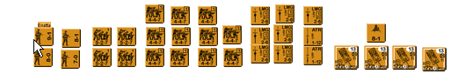
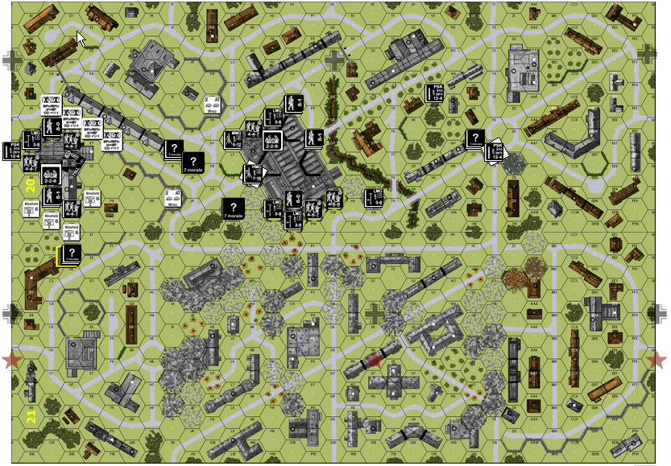
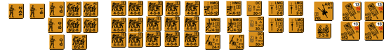
DEFENDER: GERMAN

Do not forget about PF and ATMM mines [C13.7]. PF back blast is applicable in rubble but not in a factory.

HIP Fortified Building (Ground Level): 20Q9, 20O10, 20M8, 20B6, 20P9, 20C6, 20N9

HIP Roadblock: 20C4/D3, 20Q3/R2 HIP 6 FP AP Minefield: 20D10, 20E9, 20C10, 20B9

HIP 2 Factor AT Minefield: 20K5, 20I9 HIP Wire: 20D5, 20C5, 20E6, 20F6

21D1: Building Level 2 (4) Dummies 20I7: (4) Dummies 20X6: (3) Dummies

20J7: (2) Dummies (Simulated Tank) [J6/K7] 20L9: (2) Dummies (Simulated Tank) [K10/L10]

20S9: HIP 5-4-8/LMG 20A7: HIP 2-3-8/PSK 20V4: HIP 2-3-8/PSK

20Y7: ? JgPz IV/70 [X7/Y8] 20Y7: HIP 4-6-8/PSK

NORTH FACTORY

20M8: ? JgPz IV/70 [L7/L8]
20N6: HIP 2-2-8, 75L AT [M6/N5]

20O10: ? 5-4-8/LMG
20O9: ? 8-0
20M6: ? 4-4-7
20Q9: ? 4-6-8
20P9: ? 4-4-7
20M8: ? 9-1, 4-6-8/HMG
20N5: ? 5-4-8/LMG
20P6: ? 8-1, 4-6-8/MMG
20O5: ? 8-1, 4-6-8/HMG
20N9: ? 5-4-8/LMG
20L6: ? 4-6-8/MMG

SOUTH FACTORY

20D7: ? JgPz IV/70 [E7/E8]
20C8: HIP 2-2-8, 75L AT [ D8/C9]

20D9: ? (2) 4-4-7
20B6: ? 5-4-8/LMG
20B7: ? 4-4-7
20D6: ? 4-4-7
20C9: ? 8-1, 4-6-8/MMG
20C6: ? 8-0, 5-4-8/LMG

ATTACKER: RUSSIAN

